Thank you for submitting your work to be considered for publication in CommonHealth! Please use this template, as well as resources provided on our website when creating your submission.

Basic guidelines:
- Written in English
- Body of manuscript may not exceed 20 pages (excluding references)
- Font
  - Use a standard font (e.g., Arial, Times New Roman)
  - 12-point font for body
  - 14-point font for header
- Paragraph
  - Left justified text
  - Indent paragraphs
  - Double-spaced lines
- Use numbered lines
- AMA style formatting

Clear and Concise Title of Project

Author 1 First and Last Name¹, Author 2 First and Last Name¹, Author 3 First and Last Name² …

¹Affiliated department and institution for Authors 1 & 2
²Affiliated department and institution for Author 3

KEYWORDS: List three to six keywords that describe your project.

Acknowledgements
Include acknowledgements here. Suggested length 2-4 sentences.

Authors’ Contributions to Work
Describe each author’s contribution to work. Suggested single sentence per author, with maximum length 5 sentences.

Conflicts of Interest
Disclose any potential conflicts of interest. If none, declare no conflicts.

Funding Sources
State funding sources and/or agencies.

Contact information for corresponding author:
Full Name
e-mail@domain.com
Mailing Address
City, State, Zip code

Lay Abstract
Include a lay abstract summarizing the article, to be used by the journal when promoting your article on social media. This section should not include jargon or any technical terminology that is not immediately familiar to the average reader. Suggested length 100 words.
Lay Abstract Requirements
-A lay abstract is required for original research papers and reports.
-Although encouraged, a lay abstract is NOT required for other submission types.

Abstract
Directions for structured abstracts:
OBJECTIVE: State the importance or overall objective of your article. Specify research questions as appropriate. METHODS: Describe the experimental design and methods used to address the research questions. RESULTS: Summarize main results, stating whether hypotheses were supported or not. CONCLUSIONS: State main conclusions from results. Consider contextualizing your findings and relating them to clinical practice if applicable. Word limit: 250 words.

Directions for unstructured abstracts:
Write a paragraph summarizing the objective, methods (if applicable, main results, and conclusions from the article. Do not use headings. Word limit: 250 words.

Abstract Requirements
-Abstract should be included on separate page
-Structured abstract required for: original research, systematic reviews.
-Unstructured abstract required for: narrative reviews, case reports, teaching/supervisory practice reports.
-Abstracts NOT required for: research letters, op-eds, letters to the editor.

Clear and Concise Title of Project (Research Papers)
Here is where you will include your Introduction. Suggested length is 3-5 paragraphs. No heading is needed for this section. All new paragraphs should be indented. Refer to the American Medical Association (AMA) Manual of Style (11th Edition) or the International Committee of International Committee of Medical Journal Editors (ICJME) Uniform Requirements for Manuscripts Submitted to Biomedical Journals for guidance on suggested length and content of the Introduction.
Use superscript numbers¹ to include citations as needed. References should be numbered in the order of their appearance in the text.² Place superscript numerals outside of commas,³ and periods.³ Superscript numerals should be placed inside of⁴: colons and semicolons. If you cite a paper multiple times, use the same number for all citations.¹ To cite more than one paper, use commas^{2,4} to show nonconsecutive citations and hyphens to show a consecutive list of citations.⁵⁻⁷
You may also choose to use in-text citations. Use author last names only, and include numeric subscript citations following the author names. For works with one or two authors, include both names. For works with three or more authors, include the first author’s name followed by “et al” or “and colleagues.” For a research group, state the name of the group. Refer to the following paragraph for examples of different citation types.
The two most popular flavors of ice cream in the United States are chocolate and vanilla.⁸ There is disagreement on the most popular ice cream toppings⁹⁻¹⁰; individuals report shifting preferences when surveyed at different times of the year.¹¹ Similarly, a recent report from Jones and Smith¹² suggests that ice cream sales fluctuate throughout the year, with the highest sales in July. Longitudinal data from the Cone Study Group found that people are most likely to buy ice cream when temperatures are above 70 degrees Fahrenheit.¹³
Generally, the introduction of your paper should include a literature review. This will lead to the present project. Your introduction should end with the main research questions/objectives and relevant hypotheses.
Methods
This section begins with a Level 1 heading – bold font, flush to left side of paper. Indent all new paragraphs. Suggested length is 3-5 paragraphs. Include enough detail to allow for replication of project. This section may include narrative descriptions, tables, figures, and flow charts. Figures, tables, charts etc. should be numbered according to their appearance in the manuscript. Use separate numbering for each type of visual (e.g., Figure 1, Figure 2, Figure 3, Table 1, Table 2). When submitting your article, do not embed tables/figures in the text. Include all tables at the end of the document, with each labeled table on a separate page. Include figures in separate file, with one figure per file. Use brackets [ ] to demarcate correct placement of figures/tables in manuscript. This allows for ease of review and copyediting. See end of Participants section for example. Content of this section will depend on the type of submission and study design. For guidance on what to include, refer to the AMA manual of style or EQUATOR Network guidelines. Commonly used resources available through the EQUATOR network include the CONSORT checklist for clinical trials, STROBE statement for observational studies, or PRISMA statement for systematic reviews. Refer to the EQUATOR Network website for a comprehensive list of reporting guidelines by manuscript type. Hyperlinks are included in preceding sentences.
Use subheadings as needed in this section to discuss the following study features, as needed: study design or type of analysis, dates and period of study or data collection, institutional review board (IRB) or ethics committee review and approval/informed consent processes, condition or disease studied, participants details (i.e., number, demographic information, inclusion and exclusion criteria), materials used, intervention(s) or exposure(s), all outcome measures or observations used, and statistical analysis plan (include power statement if applicable). Other sections may be included as needed to describe methods. See paragraph below for an example of how to format subheadings.
Participants
This section begins with a Level 2 Heading – italicized font, flush to left side of paper. Indent all new paragraphs. All participants were recruited from hospitals within the Philadelphia area. At the onset of data collection we recruited 500 participants. To be deemed eligible for inclusion in the study, participants had to be over the age of 55 and have normal blood pressure. We randomly assigned participants to the intervention or control conditions. Throughout the study, 30 participants (n = 30) from the treatment group and 25 (n = 25) participants from the control group failed to attend final data collection sessions. Thus, we analyzed data from 445 participants (N = 445). Refer to Figure 1 for participant flow.
[INSERT FIGURE 1 HERE]
Statistical Analysis
This section begins with a Level 2 Heading – italicized font, flush to left side of paper. Indent all new paragraphs. The Methods section of the paper should end with a description of planned statistical analysis, if relevant. Consider including information related to statistical tests (e.g., alpha level, one-sided or two-sided tests, statistical power) and software/programs used to complete analysis. Refer to EQUATOR Network and AMA Manual of Style for further guidance.
Results
This section begins with a Level 1 heading – bold font, flush to left side of paper. Indent all new paragraphs. Suggested length is 5-10 paragraphs. In this section you will present the results of your analyses. To organize your results, you may choose to use subheadings, tables, or figures. All figures and tables should be numbered according to their appearance in the manuscript. Include all tables on a separate page at the end of your manuscript, do not include them in the main body. Include figures in separate file, with one figure per file. Use brackets [ ] to show editorial and copyediting teams where you would like figures etc. to be placed in the article.
Present study findings, including measurements of effect size (e.g., Cohen’s d, rate ratio) and uncertainty (e.g., confidence intervals) as appropriate. Pay careful attention to required decimal places, as well as capitalization and italics to be used for statistical symbols and abbreviations. Mathematical formulas that cannot be conveyed concisely in words should be placed in a new line, centered on the page. Consult AMA Manual of style for comprehensive guidance in reporting in Results section.
Discussion
This section begins with a Level 1 heading – bold font, flush to left side of paper. Indent all new paragraphs. Suggested length is 5-7 paragraphs. Use subheadings to organize this section if needed. This section is where you should interpret your results and state whether hypotheses were supported or not. Connect your findings to previous literature or theories.
Include commentary on limitations of project, as well as extent to which results may be generalized. If appropriate, note public health impact of findings and/or relate to clinical practice. Suggestions about future directions of research may be included but are not required. End this section by succinctly restating the main findings and their importance.

References
- Vanderpump L, Todd K. Example print journal article. BMJ. 2000;7(4):100-500. doi:#####
- Carter BI. Example online journal article. N Engl J Med. 2010. doi: #####
- Pacino A, Duvall R, Keaton D, De Niro R, Cazale J, Shire T, et al. Example Print Book. 2nd ed. Coppola Publishing; 1974.
- The Spice Girls. Example Online Book. Girl Power Publishing; 1994. Accessed October 4, 2010. https://www...
- Springsteen B; The E Street Band. Example website title. Example website name. Published July 4, 1970. Accessed May 31, 2005. https://www...
- References should begin on a new page following Discussion.
- Order all citations in numeric order according to their appearance in the manuscript.
- At minimum, references for journal articles must include author, title, abbreviated journal name, and date. References for print journal articles must also include volume, issue, and pages.
- At minimum, references for books must include author, title, edition number, publisher, copyright date. Online books must also include date accessed and URL.
- At minimum, references for websites must include author (or organization) who created website, title, name of website, date published/updated, date accessed, and URL.

In addition to example references and comments (go to Review > Tracking > Simple Markup to view comments) above, consult AMA Manual of Style (11th Edition), Citing Medicine (2nd Edition), and ICJME recommendations for references. explaining reference examples. To find accurate abbreviated journal titles, use NIH's NLM catalog.
Table 1. Participant Demographics
Variable | Total  (n=2267) | Groupª |  |  |  | Statistic
 |  | Treatment  (n=1128) | Control  (n=1139) |  | p-value |  | Effect size^{b}
Male | 49 | 50 | 48 |  | .58 |  | .18
Child Age (months) | 19.62 (3.97) | 18.02 (3.14) | 21.62 (4.12) |  | .02 |  | .21
Mother Age (years) | 31.19 (10.03) | 31.87 (10.96) | 30.33 (9.15) |  | .70 |  | .01
Annual Household Income
Less than $25,000 | 67 | 60 | 75 |  | .62 |  | .19
$25,000 - $50,000 | 26 | 33 | 17
Unknown/didn’t answer | 7 | 7 | 8
Race and Ethnicity
African American | 41 | 57 | 43 |  | .12 |  | .52
Non-White Hispanic | 48 | 39 | 46
White | 4 | 1 | 2
Other | 7 | 3 | 9
STA First Subtest | 84.56 (14.11) | 94.20 (8.62) | 72.50 (9.52) |  | <.001 |  | .61
STA Second Subtest | 89.15 (19.16) | 102 (12.67) | 73.08 (12.51) |  | <.001 |  | .58
STA Total Score | 85.93 (16.46) | 69.10 (9.10) | 95.82 (10.61) |  | <.001 |  | .64
Note. Child age, mother age, and STA scores expressed as Mean (SD). All other variables expressed as percentages.
Abbreviation: STA, Standardized Test of Anything²¹
ª Participants randomly assigned to treatment and control groups.
^{b} Effect size benchmarks based on Cohen²²: Small = .2, medium = .5, large = .8
Reminders for Formatting Tables
- Create tables in an editable Word format with data arranged in columns and rows
- Tables must be specifically referenced in the text with a bracketed note for placement.
- Present each table on a separate page, following body of the manuscript and references.
- Each table needs a title – following the word ‘Table’ in bold, number the table sequentially, using Arabic numerals. Provide a brief but explanatory title. Capitalize each word in the title.
- Formatting
- Single space the entire table and notes.
- Use vertical lines minimally.
- Provide headings for each column.
- May use smaller font size inside table.
- Include information as needed to interpret the table as notes below the table.
  - General notes: Explain the table as a whole. Preceded by ‘Note.’ in italics.
  - Abbreviations: List abbreviations alphabetically after the heading ‘Abbreviation’ for single abbreviations, and ‘Abbreviations’ for multiple. Use semicolons as separators, and a period at the end.
  - Specific Notes: Use superscripts to reference specific parts of the table. List alphabetically, with each note on a new line.
  - Probability Notes: Provide p-values corresponding to symbols in the table (* p < .05, ** p < .01, *** p < .001)
- All abbreviations, symbols, and special use of italics or parentheses must be defined. If appropriate, symbols may be defined in a separate legend.
- Reference citations numerically, with corresponding citation listed on the references page.

SAVED/SUBMITTED IN SEPARATE FILE
Figure 1. Participant Flow in Study 1
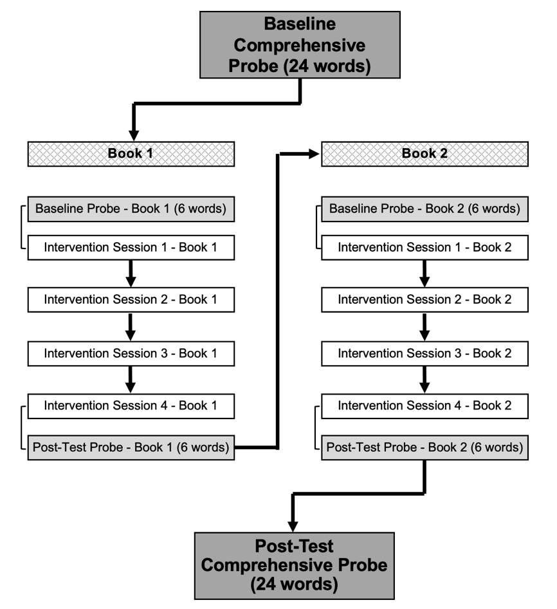
Note. Brackets adjoining probe and intervention sessions denote sequential completion of two tasks within one session.
Reminders for Formatting Figures
- Figures do not need to be in an editable format.
- Figures must be specifically referenced in the text with a bracketed note for placement.
- Save/submit each figure in a separate file.
- Each figure needs a title – following the word Figure in bold, number the figure sequentially, using Arabic numerals. Provide a brief but explanatory title. Capitalize each word in the title.
- If figures include text, ensure that text is large enough to read.
- Include information as needed to interpret the figure as notes below the table.
  - General notes: Explain the figure as a whole. May include information needed to understand color coding or symbols used in figure. Preceded by ‘Note.’ in italics.
  - Abbreviations: List abbreviations alphabetically after the heading ‘Abbreviation’ for single abbreviations, and ‘Abbreviations’ for multiple. Use semicolons as separators, and a period at the end.
- All abbreviations, symbols, and special use of italics or parentheses must be defined. If appropriate, use a separate legend.
- Make your figure accessible for people with different visual/perceptual abilities and color-blindness. Consider using patterns/textures to show contract rather than colors. If you must use color, consider using pre-existing color palettes and learning more about creating accessible visuals.

