The Power of a Park
Stephanie Cuomo
Senior, History and Secondary Education

The shuffle of feet, the chanting of voices, the shattering of bottles, the bursting of firecrackers all filled the hot, humid air of summer in New York. These noises are not to be mistaken for a boisterous Fourth of July celebration; this occasion was in fact quite the opposite. It was just past midnight on August 6th, 1988 and over two hundred demonstrators had gathered in and around Tompkins Square Park; among them was Jerry “the Peddler” Wade. Jerry, like most others present that night, was there as an advocate against the gentrifying forces that had taken hold of the Lower East Side that he calls home. For many protestors that night, those forces were embodied by the nearly one hundred police officers that were tasked with maintaining peace and order during this public display of frustration and tension. This would prove to be an impossible task for the police force as the protest deteriorated into a war zone that raged with violence between officers and the public until dawn. Within the context of the rapidly progressing gentrification and the resulting division of the community, Tompkins Square Park had become a symbol of the resistance and the Tompkins Square Riot of 1988, as it would be known, was a metaphor for the struggle of power that divided the Lower East Side.
The local usage of the term “Lower East Side” in the 1980s was more loosely referring to the area between the East River and Bowery, and 14th Street and Canal Street, the modern day boundaries of the East Village had yet to fully form above Houston St. Since the 1850’s, this area of Manhattan had a long history of absorbing successive waves of immigrants and newcomers housed in the sprawl of tenements east of Third Avenue. The Irish and Germans fleeing upheaval were replaced the Jews escaping anti-Semitism. Around the same time came Puerto Ricans seeking economic opportunity. By the 50’s and 60’s, it was the flower people and hippies searching for low rents and bringing their artistry with them. The children of the previous wave of immigrants left for the suburbs and many buildings were abandoned and left to decay during the 70’s. In the late 70’s and early 80’s, the structures of the Lower East Side were in disrepair and the people who occupied these spaces were an unconventional mixture of remaining immigrant families, drug dealers, homeless people artists, political radicals, and the most recent newcomers, the punks. For many of these people, the neighborhood has a uniquely gritty character as one resident described it to the New York Times, “’it’s almost like geographical determinism’”. Another resident called it a safe haven for the rejects of mainstream society, and fondly reflected that the area “attracts a lot of freaks”. To understand the spirit of this neighborhood in the 1980s, Tompkins Square Park serves as a revealing point of reference.
The three square block radius of Tompkins Square Park made it the second largest green space second to Central Park and in the 1980s it was one of the most intensely used public spaces in Manhattan. A large concrete band shell built in the 60s made the park a gathering place for punk and rock concerts, political rallies, and most famously for an annual drag show. The history of political activism on the grounds became one of the park’s most defining characteristics, so much so that the New York City Parks Department’s official website writes of the park, “since its beginnings in the 19th century, Tompkins Square Park has served as a place to voice dissent”. Additionally, the park had long been the site of late-night gatherings for residents but by the 80s it had also become, as one reporter described it, “a hangout for drug dealers, rowdy drunks and punk-rockers with spiked hair”. Many homeless people called the park their home, setting up semi-permanent residencies in the southern quarter of the park, where numbers had grown to a hundred and fifty people by the late 1980’s. The parks patrons were a representation of the many disparate groups that occupied the Lower East Side and there were growing tensions that fell along socio-political lines as each group claimed a legitimate right to the park. Groups were further divided as they witnessed the transformation of the neighborhood around the park with the influx of the newest group, the “yuppies” or the upper class.
The changes that were sweeping the Lower East Side in the 80s were part of a pattern of gentrification in which run-down neighborhoods were renovated, raising property values and displacing low-income families. Gentrification is not an instantaneous phenomenon but rather a gradual process that has no universally clear formula or step by step procedure. One New York City developer, Mr. Pergolis, told reporters that the renovations in the process of gentrification occur in four phases. The first of which is “marked by building deterioration and neighborhood crime”, followed by “short-term speculators”, then by “long-term investors and renovators,” and lastly by “full-scale construction”. William Sites, author of Remaking New York: Primitive Globalization and the Politics of Urban Community, argues that the public sector plays a crucial role in the process of gentrification through policy decisions and incentives that spur the redevelopment of the private sector in working class residential zones like the East Village area of the Lower East Side. He additionally cites government decisions to intentionally “pass up opportunities to stabilize existing communities through directed use of publicly held properties” and a more rational land-clearance strategy. The 1980s Lower East Side was at the mercy of the combined efforts of renovators and government policy.
The most emblematic example of the renovations that were characteristic of the gentrification of the Lower East Side is that of the Christodora building. The Christodora House was founded in the 1890s to provide social services for the immigrant community that occupied the tenement district east of Tompkins Square. Having outgrown its original structure, a new building was completed in 1928, but after World War II the organization was unable to generate enough income to continue the services and in 1947 the building was sold to the city for $1.3 million. Though the Department of Social Services continued to operate some programs in the building, by 1967 only a few ground floor rooms were still in use and the building was in a state of rapid deterioration. Despite neighborhood efforts to negotiate with the government, the building was sold for $862,500 in 1975 only to be resold two more times before being bought in 1984 for $3 million. By June 1986, the first of the buildings 86 “luxury” units were on the market, attracting new residents of the upper class, who became the faces of gentrification on the streets of the Lower East Side.
The spirit of activism and resistance that was distinctive to the people of the Lower East Side created for a multifaceted pushback against gentrification. One fundamental part of the resistance was the squatters, who organized efforts to occupy and renovate city-owned buildings that had been left to disrepair. Among their leadership is none other than Jerry the Peddler along with Frank Morales, a 38-year-old former Episcopal priest who spoke to the New York Times about their little-noticed efforts. Morales said that the movement is one aimed at the preservation of squatters’ right to maintain their dwellings and had gained momentum after police evicted squatters from a building at 537 E. Fifth Street that “triggered a month-long protest”. Their movement now includes at least 20 buildings in the Lower East Side and nearby areas that are occupied by “formerly homeless people, some elderly, and some runaways”. The squatters and their community allies helped lead a bitter but losing battle in September 1985 to preserve what they dubbed “the Garden Of Eden” which was marked for development by the city government. The squatters mobilized a resistance that proved they were not going to give up without a fight, in true Lower East Side spirit which carried through to the Tompkins Square Park resistance movements.
The large community of homeless people that had occupied Tompkins Square Park during the 1980s became organized and politicized, just like their neighbors and allies the squatters. The community built their homes on and around the existing structures in the park and the resulting encampment was dubbed “Tent City”. Their commitment to the functionality of their continued presence in the park was evident in their organization of cleaning crews that worked to maintain the public lavatories which served as the community’s source of water for drinking and bathing. By choosing to live here, the homeless put all aspects of their lives on public display and in effect they politicized their bodies, refusing to be socially invisible and marginalized. These visual politics were strategically employed even more overtly when they built a tent of four American flags, knowing the controversy and attention it would attract. Just as intended, reporters came to photograph the scene (Figure 1) and seek an explanation. One man living in the park, Chris Henry, articulated the act to one reporter in that, “shelter is not being provided by America, so we've got to use the symbol of America to shelter ourselves”. The homeless were making a clear public statement that they had the right to remain in the park so long as gentrifying forces continued to turn properties into luxury housing, ignoring the needs of the local people.
As the neighborhood continued to change and the divisions among groups deepened, Tompkins Square Park became the battle ground for these tensions to spill out. Some of the older residents and some of the new affluent newcomers expressed increasing discontent with the rowdy activities in the park late at night as well as their perceived threat of illicit activities such as drug dealing and the encampment of the homeless within the park. These complaints were voiced at a meeting of Board 3 on June 28th, 1988, during which members approved a report that included the recommendation for a 1 AM curfew for Tompkins Square Park. No action was taken until July 11th, when noise and nuisance complaints by community members prompted the police to evict all but the homeless and the park was closed in similar fashion periodically over the next two weeks. Members of the area’s political counter-culture adopted the closing as a personal cause and leaders, like Jerry the Peddler, printed leaflets calling for a rally on Saturday July 30th. That night, fewer than fifty officers dispersed fifty to a hundred protestors, arresting Jerry the Peddler and three others. Organizers told the press that the “idea was to bring people peacefully to the park” but in regards to the violence and arrests, one organizer cited the inevitably of a confrontation because of what he called a “class war between the richer, backed by the police, and poorer residents” of the neighborhood. Many shared this view and another protest was set for the following week.
On Friday August 5th a small but calm gathering of protestors was evicted from the park without incident. However, as night fell on Tompkins Square Park the following day, Saturday August 6th, 1988, there was a growing crowd of protestors that amassed to roughly 250 people by 11:00 PM. Around the same time, Police Captain McNamara, the highest ranking officer on the scene with 86 officers and 11 on horseback under his command, told reporters, “’it's time to bring a little law and order back to the park and restore it to the legitimate members of the community’”. Around 11:30 PM, protestors were captured in photographs by Angel Franco for the New York Times, waving banners proclaiming “Gentrification is Class War” (Figure 2), shouting obscenities, drinking beer, and occasionally setting of powerful M-80 firecrackers. By 12:30 AM most of the protestors had left the park but had massed in the street and began throwing bottles. As officers were hit by flying bottles, tensions grew to a breaking point at around 12:55 AM when the mounted officers charged the crowd of protestors and violence erupted that would continue for the next six hours. The deeper ideological stance that the protestors originally intended to represent that night was demonstrated in the final act of lawlessness. Around 6 AM, protestors rammed a police barricade through the glass doors of the newly renovated, luxury apartment building, the Christodora.
The hours of violence that ensued that night turned the streets of the Lower East Side into a battleground in which the resistance was going into hand to hand combat with the forces that backed the gentrification of their neighborhood. The blame for the violence should be evenly distributed between the protestors and police as there is irrefutable evidence of unlawful actions taken by police officers that night. A local artists and videographer, Clayton Patterson, was at Tompkins Square that night recording the scene unfolding. In his 3 hours of recorded footage, officers are seen without badges or their badge numbers are concealed with black material before any outbreak of violence even begins. This fact, along with McNamara’s statement to the press, paints an image of the police force’s actions as premediated intention to incite a riot.
Additionally, many of the individuals who were involved in the violence were involved not the ones to incite aggression and violence that night. Patterson’s video as well as innumerable eye-witness accounts prove that there were many unprovoked attacks by police on bystanders. One of the most heinous of these was Jeff Dean Kuipers, who was walking by the scene with a female companion when officers told his friend, ''Move along, you black n****r bitch''. To which Kuipers only managed to turn around and stutter, “What?” before five officers had knocked him down and were beating him with nightsticks, breaking his nose. Clayton’s video also corroborates testimonials of many instances of police use of extreme force. In the end, 44 people were left injured, 13 of which were officers and within a week, 121 official complaints of police brutality were filed. Two days after the riot, Police Commissioner Benjamin Ward told a press conference that inadequate deployment and supervision of officers was partly to blame for the clash of police with protestors that night. In the aftermath of the riot, a handful of high-ranking commanders on duty that night were reprimanded, transferred or forced into early retirement, but not one of the 14 officers tried on brutality charges was convicted. The public’s reactions to the riot and to the police actions largely condemned the police force as all the major news channels repeatedly played the horrific footage recorded that night.
Public outcry following the riots was largely centered on criticisms of the officers’ actions and less on the foundations of the protest. The dialogue surrounding the police overshadowed the issue of gentrification and the resistance movements that opposed it. This was evident in the art and music that was produced in reaction to the riots. The song titled “Hold On” by rock musician Lou Reed which appeared on his 1989 record titled ‘New York’ is a prime representation of the public outcry following the riots. In opening of the song the lyrics read, “there's no such thing as human rights when you walk the N.Y. streets,” and the chorus ends with the line “I’ll meet you in Tompkins Square” which then changes to “there’s a riot in Tompkins Square” in the second refrain. Reed was referring to the violations of human rights committed by officers in the first line as well as explicitly referring to the riot itself. However, there is no mention of gentrification or any of the opposing resistance movements.
As more young, affluent, and artistically inclined individuals moved into newly renovated spaces in the early 1980’s, the spirit of the Lower East Side undeniably mixed the gritty and dangerous side of the decrypt areas with the artistic and adventurous spirit of the gentrifying areas. As artistry flourished in this spirit, there was surprisingly no guarantee of “an advocacy art practice or a stance of critical resistance” among this growing part of the community. In fact, many critics argue that beyond complacency, these painters and artists of the Lower East Side were “accomplices” in the neighborhood’s gentrification and subsequent displacement of its “subcultural, racial, and ethnic groups”. The art of Rainer Fetting exhibits this quite clearly in his photograph titled Winter, Tompkins Square Park (Figure 3), which depicts a barren winter landscape blanketed in snow, punctuated by a few figures huddled around trash can fire. Fetting’s vantage point for this piece was his penthouse apartment in the Christadora House, the emblematic exhibition of gentrification in the Lower East Side. As more arty and affluent people followed suit, the neighborhood would continue to transform.
The progress of gentrification in the first few years following the Tompkins Square Riot had slowed down significantly. While activists claimed this was due to the success of their resistance, economists point to the stock market crash and recession in the late 1980’s and early 90’s as the main cause for the slowing of development. This lull was short-lived, however, and by the late 1990’s gentrification was back in full force. One New York Times reporter revisited the issue on the 10th anniversary of the riot and interviewed Jerry the Peddler, who commented on the state of the resistance, “‘in many ways, it feels like we've lost the war,’”. Members of the resistance and many of the locals of the Lower East Side had largely accepted defeat and many agreed that the area’s essence as “a bastion of American counterculture and an incubator of unconventional politics had been inexorably chipped away”. The fate of the neighborhood laid in the hands of developers and the newcomers who could afford the exorbitant rents. Longtime residents complained that most of the newcomers moving into these expensive rentals were young, work-obsessed. and uninterested in civic affairs or political activism and were only there for short periods to party then move elsewhere when they’d had their fill. For locals, this new appeal of the neighborhood as a place to party was one of the many negative effects of gentrification. This was clearly evident as of the 45 establishments that served alcohol along Avenue A in 1997, 37 had opened only a few years before. The Lower East Side has continued in this trajectory as a locus of partying and transient residency and Tompkins Square Park has faced a similar progression.
The state of Tompkins Square Park has remained a contentious issue for locals and for the government following the riot in 1988. In 1989, the New York City Parks Department offered a more modest, step by step restoration plan as opposed to their 1985 proposal that would have closed the park entirely during construction. This plan was approved and began spring 1989 and finished 1990, the parks playgrounds were rebuilt, fountains restored, fences fixed, and lawns re-landscaped; focusing on the northern zone and ignoring the southern zone dominated by Tent City. The forces of gentrification and their community allies who were angered by the constant demonstrations and growing homeless population in the park pressured the Parks Department to close the park entirely in 1991 and begin large scale renovations. 300 members of the New York City Police Department, backed by command trucks stationed at all four corners of the site, surrounded Tompkins Square Park and evicted the 150 residents who were still encamped there. While the renovations may represent the victory of the forces of gentrification over the resistance, the reactions were just as contradictory as the original conflict. One woman told the New York Times in 1993, one year after the $2.1 million renovation was completed, “‘I was against what they were doing, but I am really enjoying the effects of it’”. The Times also reported that crime was down in the park which had previously been a magnet for drug use, prostitution and other street crimes. According to the New York City Parks website, since 1995, Tompkins Square Park has been partly financed by a private, nonprofit group, East Village Parks Conservancy. The website concludes that, “today, Tompkins Square Park continues to serve a diverse community, providing a peaceful, meditative environment within the bustle of city life”.

Endnotes

Figure 1. Unknown Photographer,
Source: "Tompkins Square Park Riot of 1988." NYU Journalism
Projects Sites. April 18, 2017. Accessed December 11, 2018. http://projects.nyujournalism.org/streetsofnewyork-northtompkins/2017/04/18/tompkins-square-park-riot-1988/.

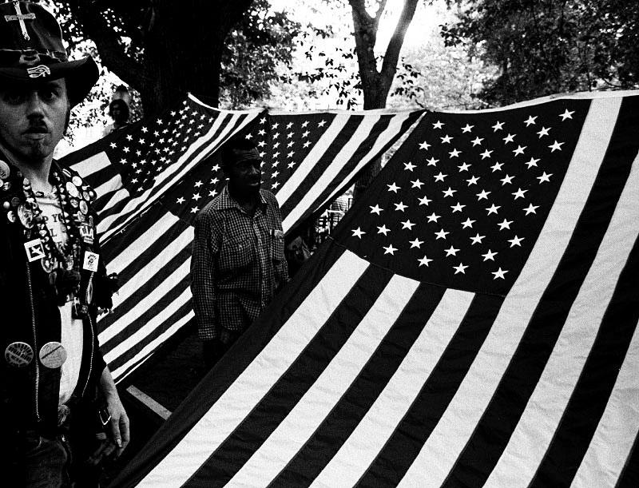

Figure 2: Photographer: Angel Franco
Source: Colin Moynihan, "20 Years After Unrest, Class Tensions Have Faded and Punk Rock Will Be Played," The New York Times, August 02, 2008, Accessed December 06, 2018,

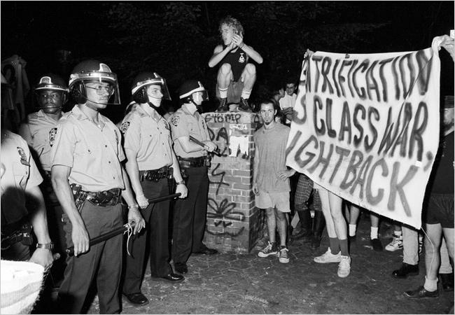

Figure 3: Photographer: Rainer Fetting
Source: Gabrielle Esperdy, "Slouching Back to the East Village: Social and Spatial Meaning in the Urban Landscape," Parallax, no. 2 (1997): 142, Accessed December 9, 2018, doi:10.1080/13534645.1997.9522394.

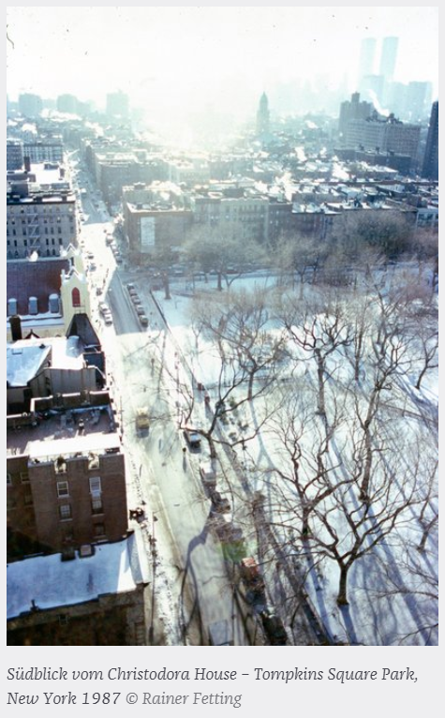

REFERENCES
Belkin, Lisa. "The Gentrification of the East Village." The New York Times.
September 02, 1984. Accessed December 06, 2018.
https://www.nytimes.com/1984/09/02/realestate/the-gentrification-of-the-east-village.html.
Belkind, Lara. "Stealth Gentrification: Camouflage and Commerce on the Lower East
Side." Traditional Dwellings and Settlements Review 21, no. 1 (2009): 21-36.
http://www.jstor.org/stable/41758710.
Bernstein, Emily M. "Tompkins Square, (Almost) United; A Year Into Park's New, Calmer Life,
Some Anger Remains." The New York Times. August 06, 1993. Accessed December 11,
2018.
https://www.nytimes.com/1993/08/06/nyregion/tompkins-square-almost-united-year-into
-park-s-new-calmer-life-some-anger.html.
Esperdy, Gabrielle. "Slouching Back to the East Village: Social and Spatial Meaning in the
Urban Landscape." Parallax, no. 2 (1997): 137-68. Accessed December 9, 2018.
doi:10.1080/13534645.1997.9522394.
Jacobs, Andrew. "A New Spell for Alphabet City; Gentrification Led to the Unrest at Tompkins
Square 10 Years Ago. Did the Protesters Win That Battle but Lose the War?" The New
York Times. August 09, 1998. Accessed December 04, 2018.
https://www.nytimes.com/1998/08/09/nyregion/new-spell-for-alphabet-city-gentrification
-led-unrest-tompkins-square-10-years.html.
Johnson, Kirk. "The Talk of the East Village; A Neighborhood of Vigorous Opinions." The New
York Times. August 13, 1988. Accessed December 04, 2018.
https://www.nytimes.com/1988/08/13/nyregion/the-talk-of-the-east-village-a-neighborho
od-of-vigorous-opinions.html.
McFadden, Robert D. "Park Curfew Protest Erupts Into a Battle And 38 Are Injured." The
New York Times. August 08, 1988. Accessed December 04, 2018.
https://www.nytimes.com/1988/08/08/nyregion/park-curfew-protest-erupts-into-a-battle-a
Nd-38-are-injured.html.
McFadden, Robert D. "27 Brutality Charges Now Filed in Clash." The New York Times. August
09, 1988. Accessed December 04, 2018.
https://www.nytimes.com/1988/08/09/nyregion/27-brutality-charges-now-filed-in-clash.h
tml.
Moss, Jeremiah. "Jerry the Peddler." Jeremiah's Vanishing New York. June 29, 2016. Accessed
December 05, 2018. http://vanishingnewyork.blogspot.com/2016/06/jerry-peddler.html.
Moynihan, Colin. "20 Years After Unrest, Class Tensions Have Faded and Punk Rock Will Be
Played." The New York Times. August 02, 2008. Accessed December 06, 2018.
https://www.nytimes.com/2008/08/02/nyregion/02tompkins.html.
Patterson, Clayton. "Tompkins Square Park Police Riot August 1988." Clayton Patterson,
CAPTURED, Video4free 2009. Accessed December 06, 2018.
http://patterson.no-art.info/video/1988_tompkins.html.
Purdum, Todd S. "Experts Are Critical Of Police Handling Of Protest in Park." The New York
Times. August 09, 1988. Accessed December 04, 2018.
https://www.nytimes.com/1988/08/09/nyregion/experts-are-critical-of-police-handling-of
-protest-in-park.html.
Purdum, Todd S. "Lessons of 60's Forgotten in Park Riot." The New York Times. August 11,
1988. Accessed December 04, 2018.
https://www.nytimes.com/1988/08/11/nyregion/lessons-of-60-s-forgotten-in-park-riot.ht
ml.

Andrew Jacobs, "About Real Estate; Low-Cost Rental Units for East Village", The New York Times, August 12, 1988, Accessed December 04, 2018, https://www.nytimes.com/1988/08/12/business/about-real-estate-low-cost-rental-units-for-east-village.html.
Jacobs, “About Real Estate; Low-Cost Rental Units for East Village.”
Kirk Johnson, “The Talk of the East Village; A Neighborhood of Vigorous Opinions,” The New York Times, August 13, 1988, Accessed December 04, 2018, https://www.nytimes.com/1988/08/13/nyregion/the-talk-of-the-east-village-a-neighborhood-of-vigorous-opinions.html.
Johnson, “The Talk of the East Village; A Neighborhood of Vigorous Opinions.”
Todd S. Purdum, "Melee in Tompkins Sq. Park: Violence and Its Provocation," The New York Times, August 14, 1988, Accessed December 04, 2018, https://www.nytimes.com/1988/08/14/nyregion/melee-in-tompkins-sq-park-violence-and-its-provocation.html
Gabrielle Esperdy, "Slouching Back to the East Village: Social and Spatial Meaning in the Urban Landscape," Parallax, no. 2 (1997): 142, Accessed December 9, 2018, doi:10.1080/13534645.1997.9522394.
"Tompkins Square Park." Central Park: NYC Parks. Accessed December 04, 2018. https://www.nycgovparks.org/parks/tompkins-square-park/history.
Robert D. McFadden, "Park Curfew Protest Erupts Into a Battle and 38 Are Injured," The New York Times, August 08, 1988, Accessed December 04, 2018, https://www.nytimes.com/1988/08/08/nyregion/park-curfew-protest-erupts-into-a-battle-aNd-38-areinjured.html.
Esperdy, "Slouching Back to the East Village: Social and Spatial Meaning in the Urban Landscape," 149.
Ibd. 149.
Lisa Belkin, "The Gentrification of the East Village," The New York Times, September 02, 1984, Accessed December 06, 2018, https://www.nytimes.com/1984/09/02/realestate/the-gentrification-of-the-east-village.html.
Lara Belkind, "Stealth Gentrification: Camouflage and Commerce on the Lower East Side," Traditional Dwellings and Settlements Review 21, no. 1 (2009): 23, http://www.jstor.org/stable/41758710.
Belkind, "Stealth Gentrification: Camouflage and Commerce on the Lower East Side," 23.
Esperdy, "Slouching Back to the East Village: Social and Spatial Meaning in the Urban Landscape," 157.
Ibd, 158.
Ibd, 158
Ibd, 159.
Michael Wines, "Class Struggle Erupts Along Avenue B," The New York Times, August 10, 1988, Accessed December 04, 2018, https://www.nytimes.com/1988/08/10/nyregion/class-struggle-erupts-along-avenue-b.html. Wines, "Class Struggle Erupts Along Avenue B."
Michael Wines, "Class Struggle Erupts Along Avenue B.”
Wines, "Class Struggle Erupts Along Avenue B."
Esperdy, "Slouching Back to the East Village: Social and Spatial Meaning in the Urban Landscape," 150.
Idb, 152.
Idb, 154.
Purdum, "Melee in Tompkins Sq. Park: Violence and Its Provocation.”
McFadden, "Park Curfew Protest Erupts Into a Battle and 38 Are Injured."
Wines, "Class Struggle Erupts Along Avenue B."
Ibd.
Purdum, "Melee in Tompkins Sq. Park: Violence and Its Provocation.”
Ibd.
Ibd.
Purdum, "Melee in Tompkins Sq. Park: Violence and Its Provocation.”
Purdum, "Melee in Tompkins Sq. Park: Violence and Its Provocation.”
McFadden, "Park Curfew Protest Erupts Into a Battle and 38 Are Injured."
Ibd.
Andrew Jacobs, "A New Spell for Alphabet City; Gentrification Led to the Unrest at Tompkins Square 10 Years Ago. Did the Protesters Win That Battle but Lose the War?" The New York Times, August 09, 1998, Accessed December 04, 2018, https://www.nytimes.com/1998/08/09/nyregion/new-spell-for-alphabet-city-gentrification-led-unrest-tompkins-square-10-years.html.
Todd S. Purdum, "Experts Are Critical Of Police Handling Of Protest in Park," The New York Times, August 09, 1988, Accessed December 04, 2018, https://www.nytimes.com/1988/08/09/nyregion/experts-are-critical-of-police-handling-of-protest-in-park.html.
Jacobs, "A New Spell for Alphabet City; Gentrification Led to the Unrest at Tompkins Square 10 Years Ago. Did the Protesters Win That Battle but Lose the War?"
Lou Reed, "Hold On," Recorded 1988, In New York. Lou Reed, Fred Maher, 1989.
Esperdy, "Slouching Back to the East Village: Social and Spatial Meaning in the Urban Landscape," 156.
Ibd, 156.
Ibd.
Jacobs, "A New Spell for Alphabet City; Gentrification Led to the Unrest at Tompkins Square 10 Years Ago. Did the Protesters Win That Battle but Lose the War?"
Ibd.
Ibd.
Ibd.
Esperdy, "Slouching Back to the East Village: Social and Spatial Meaning in the Urban Landscape," 142.
Ibd.
Marci Reaven, "Lower East Side Preservation Initiative," A History of Tompkins Square Park, Accessed December 11, 2018, http://www.lespi-nyc.org/history/a-history-of-tompkin-square-park.html.
Emily M. Bernstein, "Tompkins Square, (Almost) United; A Year Into Park's New, Calmer Life, Some Anger Remains," The New York Times, August 06, 1993, Accessed December 11, 2018, https://www.nytimes.com/1993/08/06/nyregion/tompkins-square-almost-united-year-into-park-s-new-calmer-life-some-anger.html.
“Tompkins Square Park”.
Ibd.

